ORIGINAL OUTPUT

TAYLOR HERB HW 1

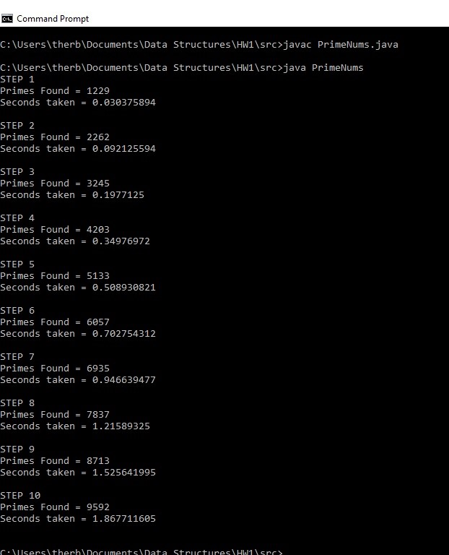

N VALUE

10000 20000 30000 40000 50000 60000 70000 80000 90000 100000